Henzi Kou

CIS 471: Introduction to Artificial Intelligence

Prof. Thanh H. Nguyen

30 October 2019

Homework 2

1. **Campus Layout**
   1. Provide the domains of all variables after unary constraints have been applied.

|  |  |  |
| --- | --- | --- |
| **(1, 1)**  A, C | **(1, 2)**  C, D | **(1, 3)**  A, B, C, D |
| **(2, 1)**  C, D | **(2, 2)**  A, C | **(2, 3)**  A, B, C, D |

* 1. Enforce

|  |  |  |
| --- | --- | --- |
| **(1, 1)**  C | **(1, 2)**  C, D | **(1, 3)**  A, B, C, D |
| **(2, 1)**  C, D | **(2, 2)**  A, C | **(2, 3)**  A, B, C, D |

* 1. Enforce

|  |  |  |
| --- | --- | --- |
| **(1, 1)** | **(1, 2)**  C, D | **(1, 3)**  A, B, C, D |
| **(2, 1)**  D | **(2, 2)**  A, C | **(2, 3)**  A, B, C, D |

* 1. ,
  2. Enforce remaining constraints in queue.

|  |  |  |
| --- | --- | --- |
| **(1, 1)** | **(1, 2)**  C, D | **(1, 3)**  A, B, C, D |
| **(2, 1)**  D | **(2, 2)**  A, C | **(2, 3)**  A, B, C |

* 1. B
  2. (2, 3)
  3. Provide the domains of all variables after assignment of LCV is applied.

|  |  |  |
| --- | --- | --- |
| **(1, 1)** | **(1, 2)** | **(1, 3)**  A |
| **(2, 1)**  D | **(2, 2)**  C | **(2, 3)**  B |

1. 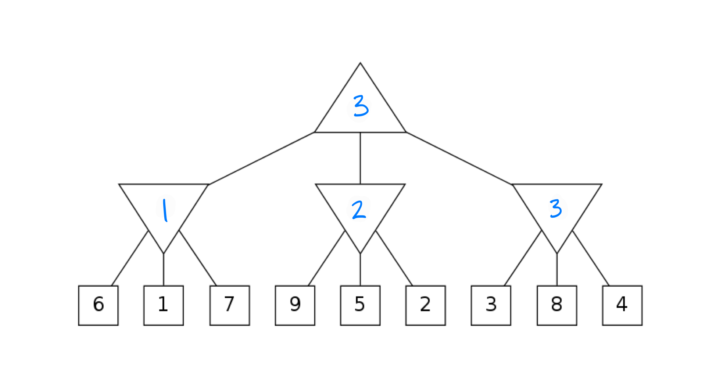**Minimax and Expectimax**
   1. 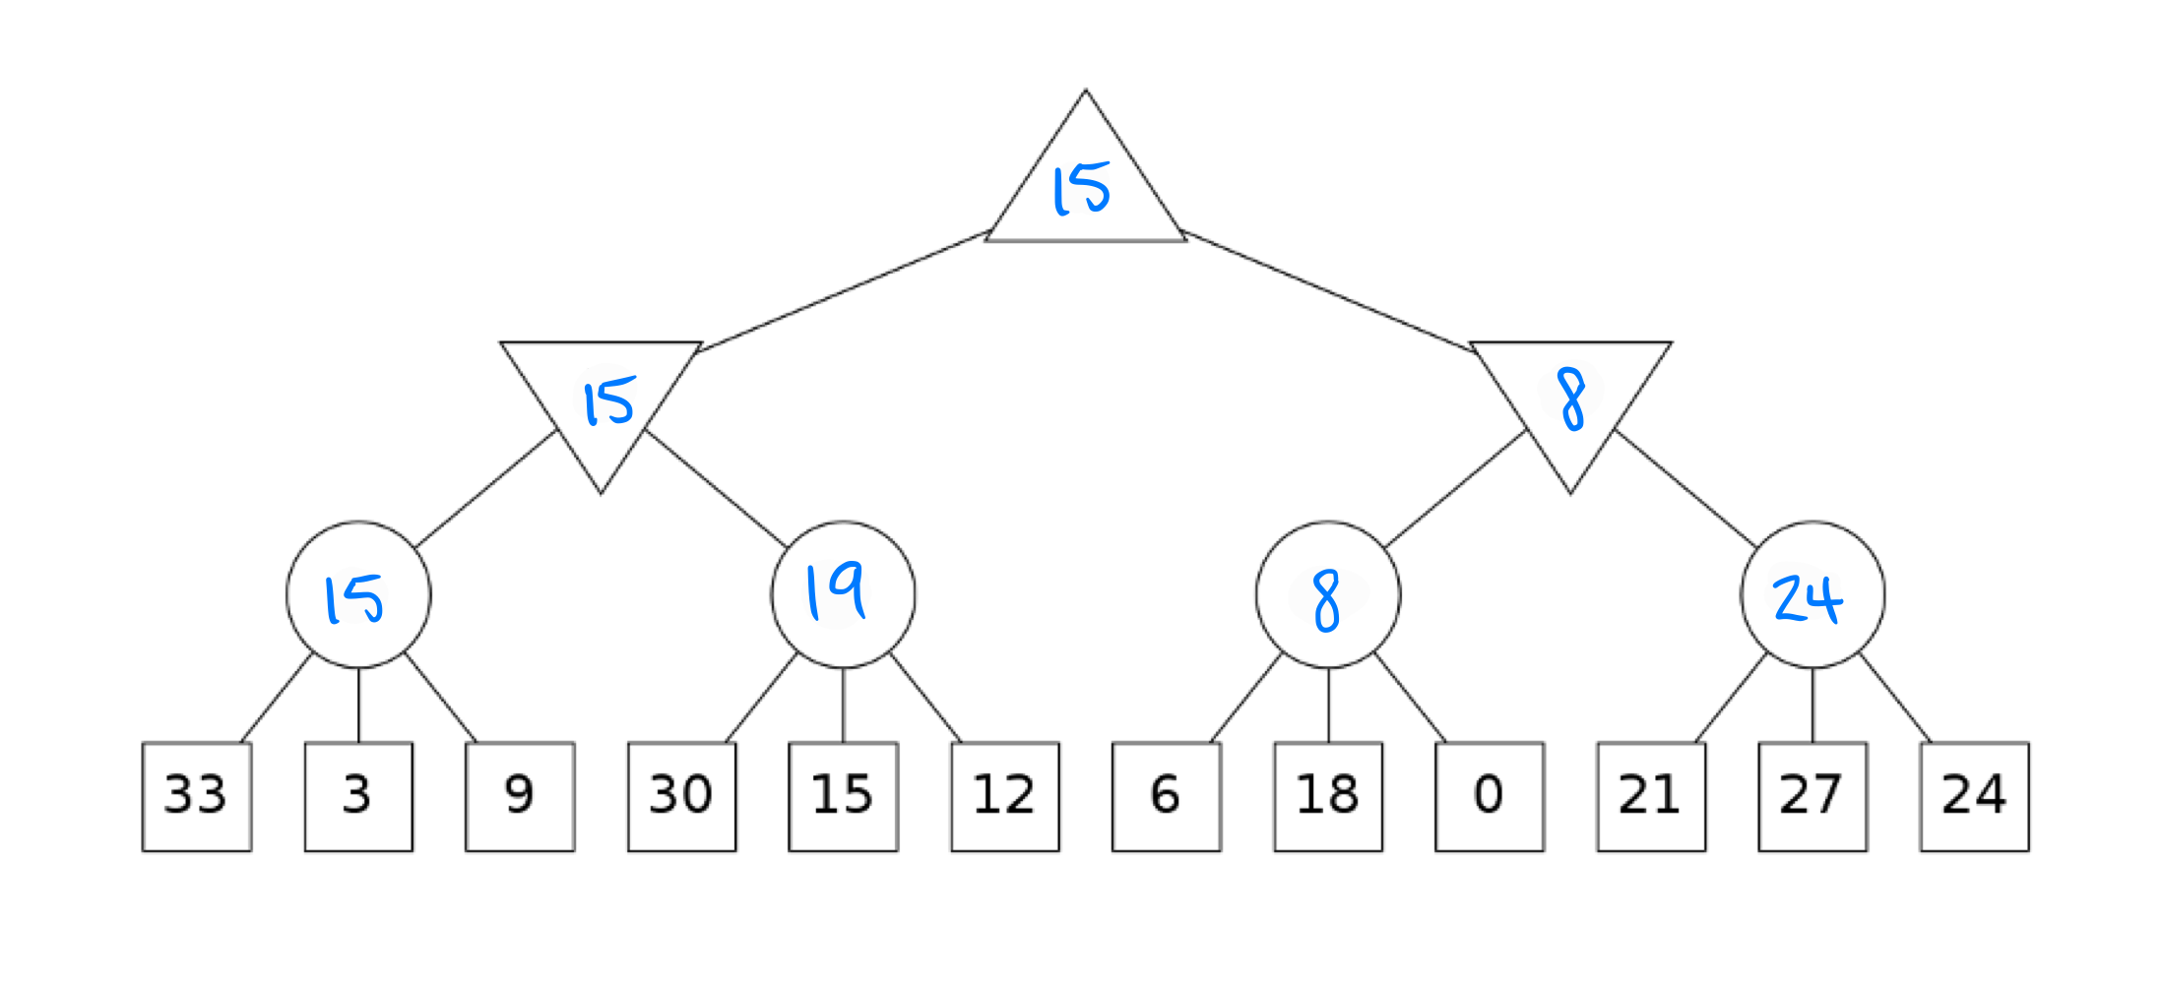Minimax



* 1. Expectimax



1. **Unknown Leaf Value**
   1. x > 8
   2. x > 9
   3. 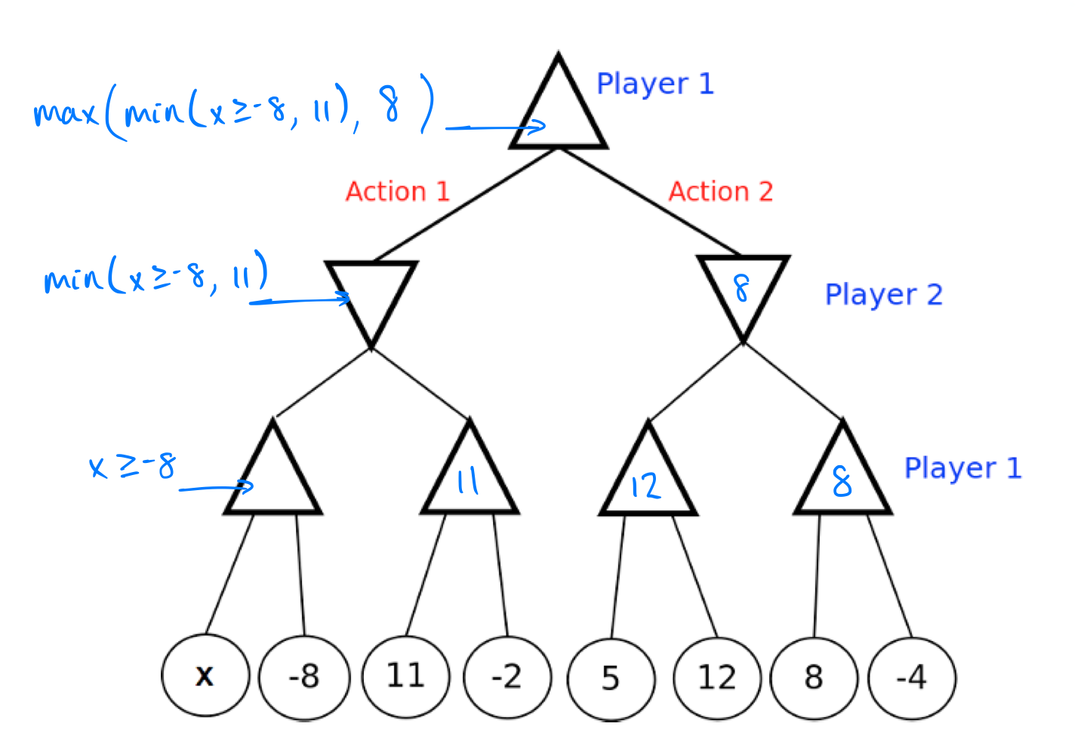Player 2 (minimax):

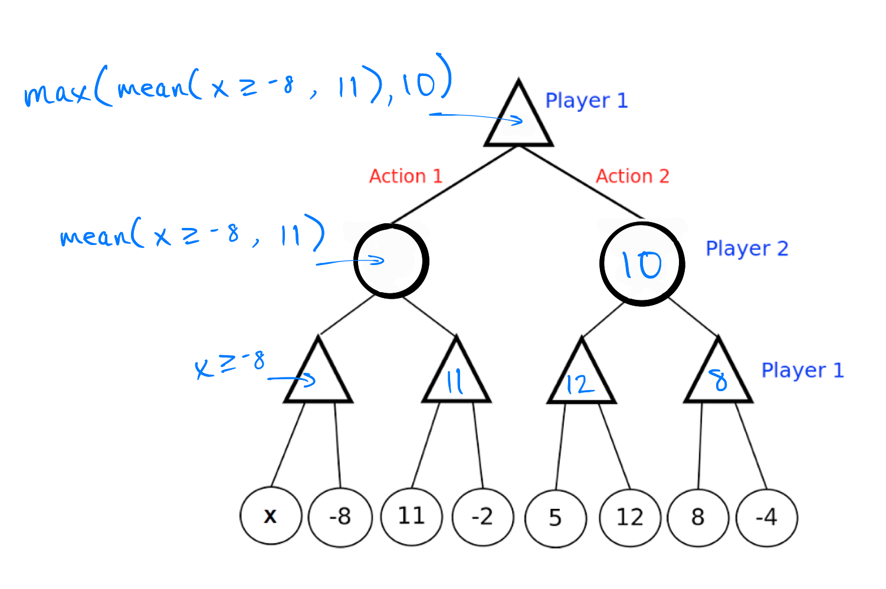Player 2 (expectimax):

No values of *x* will result in minimax value > expectimax value.

* 1. No

1. **Alpha-Beta Pruning**
   1. 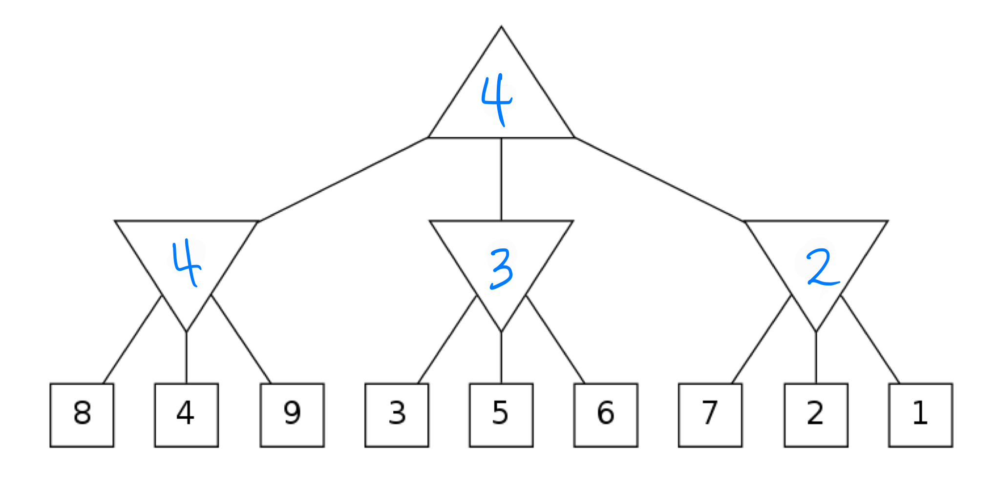Enter the values of the labeled nodes.



* 1. 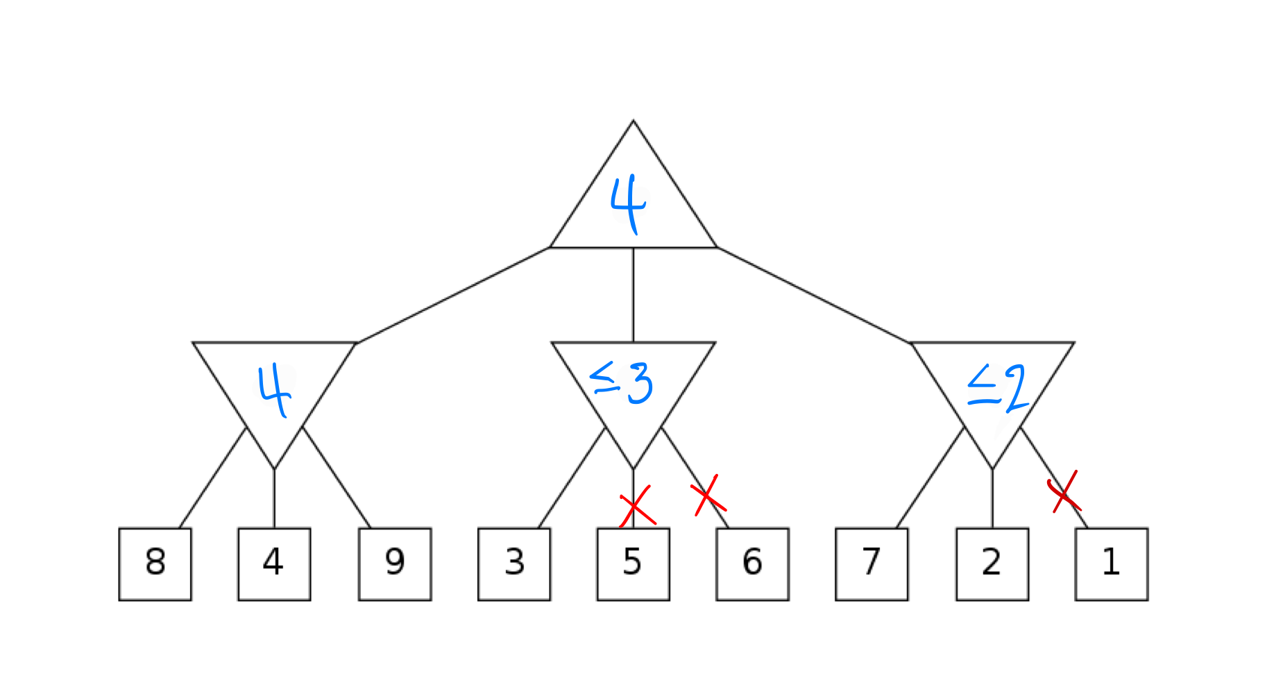Select the leaf nodes that don’t get visited due to pruning.